**NALAIYA THIRAN**

**WEEK 4 REPORT**

**Phase 2 Description:** Ideation Phase (Literature Survey, Empathize, Defining Problem Statement, Ideation)

2.5 List the ideas (atleast 4 per each team member) by organizing the brainstorming session and prioritize the top 3 ideas based on the feasibility & importance

**BRAINSTORMING**

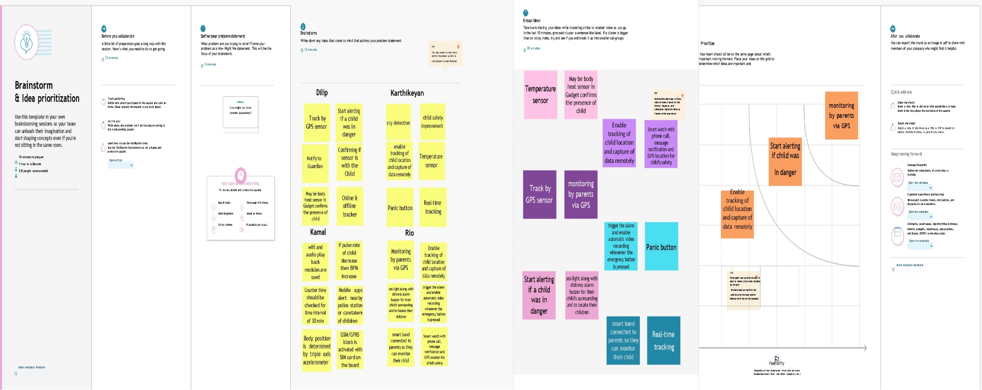

**IDEATION**

**Idea 1:**

The device has IoT monitoring and a GSM module that allows the child to be monitored at all times. It also has numerous sensors that are connected to a CPU and are used to detect exact signals such as heart rate, temperature, and other dangers and alert the parents. In the event of a power outage, the wearable serves as a backup. On the device, there is an additional panic button. The purpose of this button is to notify parents and the police of a child's current location whenever they are in a perilous scenario. A GPS module is utilized to access their present location, and a GSM module assists in transmitting the information via SMS to designated contacts. In this approach, the device tries to provide child safety while remaining unobtrusive.

# Idea 2:

Our proposed system is based on the Internet of Things-based Smart Child Safety Wearable Device System designed as an efficient and low-cost IoT- based system for monitoring infants in real-time. This system plays a key role in providing better care for the lost children until they reconvene with the parents. In this present era, most of the wearable devices today are designed based on the location, activity, temperature, pressure etc. of the child and inform the parents via GPS. Therefore, it is intended to use voice call as the way of communication between the parent mobile and child’s wearable device. The system operates on the microcontroller board and the functions of sending and receiving notifications, calls, voice messages via GPS.

# Idea 3:

A portable device which will have a pressure switch. As soon as an assailant is about to attack the person or when the person senses any insecurity from a stranger, he/she can then put pressure on the device by squeezing or compressing it. Instantly the pressure sensor senses this pressure and a conventional SMS, with the victim’s location will be sent to their parents/guardian cell phone numbers stored in the device while purchasing it, followed by a call. If the call is unanswered for a prolonged time, a call will be redirected to the police and the same message will be sent. Additionally, if the person crosses some area which is usually not accessed by the person then a message with the real-time location is sent to the parent/guardian's phone via conventional SMS.

**2.6** Attended the technology trainings as per the training calendar

**IoT-B4-4M6E (Morning Session)-Day-5 (15.09.2022)** 